AT-RISK PLANTS SOCIAL MEDIA POSTS
Post #1
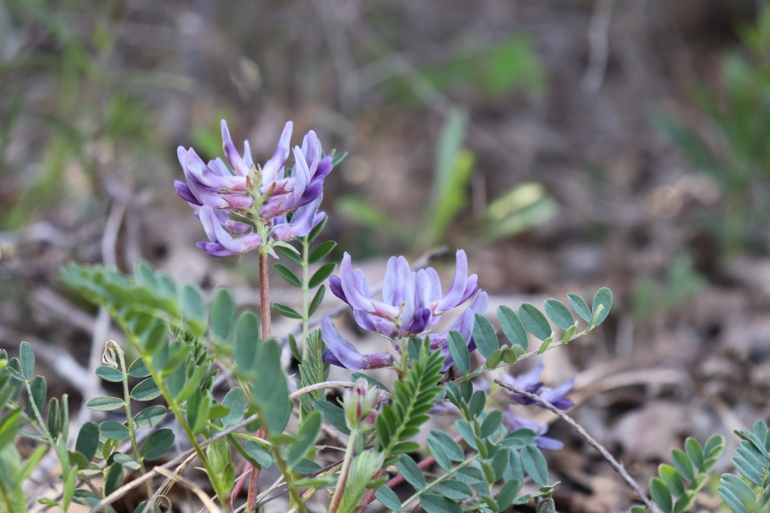
Pyne’s ground-plum is a long-lived perennial in the pea family that is restricted to limestone cedar glades in the Central Basin of Tennessee. It is classified as critically imperiled by NatureServe due to the threats of highway right-of-way maintenance, off-road vehicle traffic, trash dumping, livestock grazing and encroachment of more competitive herbaceous and woody plants. Help at-risk plants like this one—pass the Recovering America’s Wildlife Act. Take action. #recoverwildlife
Photo by David Pineros, Tennessee Division of Natural Areas.

Post #2
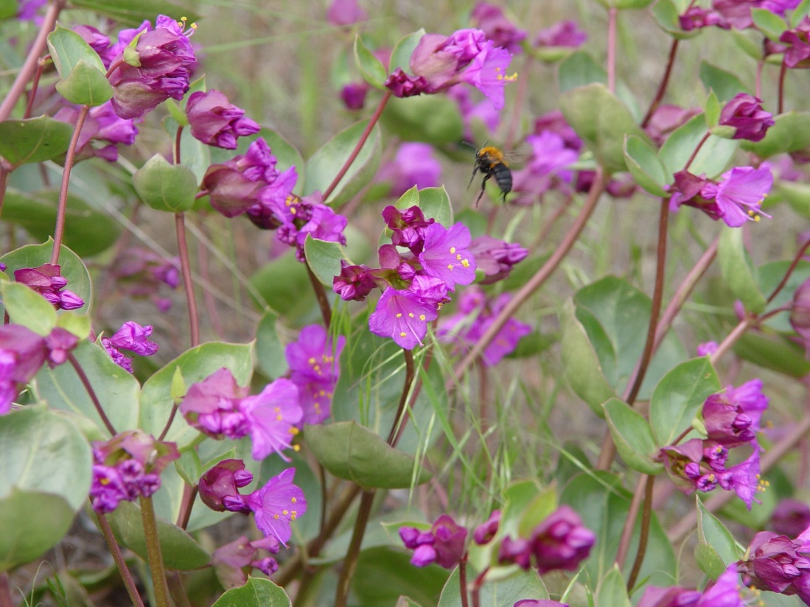
Macfarlane’s four-o'clock has only 13 known locations across Idaho and Oregon. It is classified as critically imperiled by NatureServe due to the threats of livestock grazing and the invasion of exotic plants. Take action to pass the Recovering America’s Wildlife Act. #recoverwildlife
Photo by Michael Baird (iNaturalist.org).

Post #3
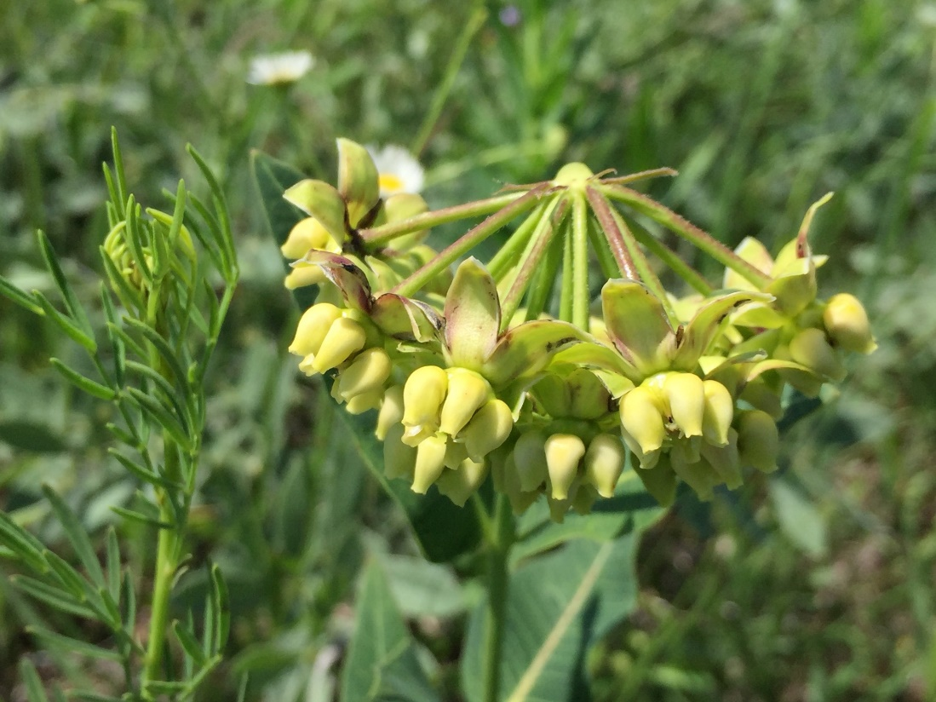
Mead’s milkweed is found in the tallgrass prairies of the Midwest. It is classified as imperiled by NatureServe due to the threats of habitat loss from land development and damage from invasive species. How can you help at-risk plants like this one? Urge Congress to pass the Recovering America’s Wildlife Act. #recoverwildlife
Photo by Mark Fishbein (iNaturalist.org).

Post #4
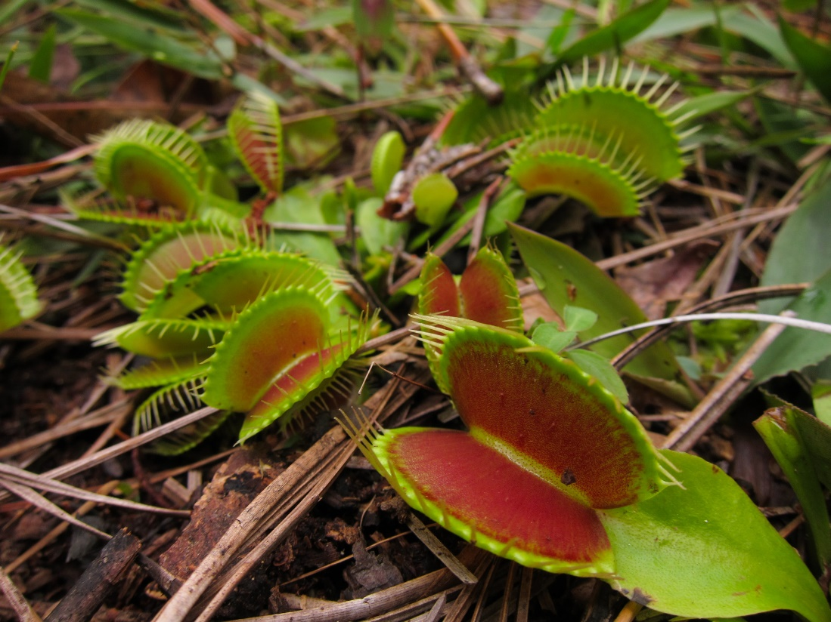
The Venus flytrap is an iconic carnivorous plant that only occurs naturally on the coastal plain of the Carolinas. It is classified as imperiled by NatureServe due to multiple threats including collection from wild populations, habitat conversion, and fire suppression. Let’s ensure these unique plants are around for future generations to enjoy. Tell Congress to pass the Recovering America’s Wildlife Act. Take action. #recoverwildlife
Photo by Miguel Vieira (iNaturalist.org).

Post #5
Compared to animals, at-risk plants are less likely to receive legal protection, and fewer resources are directed toward their conservation and recovery. This could change with the Recovering America’s Wildlife Act. Take Action Today. #recoverwildlife

