Campaign Planning Session:

REVIEW: Go over the Organizational/Campaign Goal, Strategy, Timing, and Potential Targets.

Tiering Targets:
In your conversation leading up to a campaign planning session, you would have established your criteria for picking targets and would come to this meeting with a sense of the full universe of potential targets. As a larger group during your campaign planning session, you would then tier these targets with a focus of establishing which are FIELD TARGETS where you would like to engage/employ folks on the ground in their state to push that target as well as establishing the level of engagement. Some questions that will help you to determine where to put field resources:
- Is there an existing organizational relationship we can leverage?
- Is a field strategy necessary to move this target?
- Is this someone we have the ability to influence as an organization/movement? Is our organization the right messenger?
- Legislative leads may have “scored” the targets with a number 1-5. Based on the key strategy you identified, which potential targets are a priority? For example:
  - Goal: Pass legislation no one has heard of;
  - Strategy: build champions in congress, elevate the issue and the solution with the public
  - Target: members of congress who scored a “1-2” are most likely to become champs

Targets:
1. _______________________
2. _______________________
3. _______________________
4. _______________________

Stakeholder Mapping: Identifying the key stakeholders who are most impacted by the problem or issue that is being addressed by the campaign.
- Who is on the frontlines of feeling the impacts of this problem?
- What constituency groups (hunters/anglers, business leaders), demographic groups (race, age, socio-economic status, Tribal membership, etc.), or geographic groups (along the train tracks, near the coal plant, downstream from the refinery, etc.) are most connected to the campaign?
- Who owns the story of this campaign?

Stakeholder Groups/Individuals:
1.__________________________
2.__________________________
3.__________________________

Power-Mapping: Identifying the specific people, organizations, or businesses which have the ability to strongly influence your target decision-maker. This is particularly valuable in meeting any short-term policy goals. However, this exercise is focused on influencing those who already have political power. Through an equity lens, this may ignore those who have been disenfranchised or prevented from accessing that political power. Power-mapping is a great exercise, but it should not be the only thing that dictates your tactics. Be sure to consider all of your goals and strategies as a campaign when identifying tactics, not just those that fit neatly into your power-map.

If you already know your target, this would be a great opportunity to do some power-mapping of that target. However, if you have multiple targets, you should have a separate power-mapping meeting once the campaign plan is further developed.
Identify all of the players in the field that impact your target, then place them on this continuum.

Best Practices:
- Make sure that the right people are in the room for this conversation. You need the experts who really understand the targets and can answer questions and participate in this exercise.
- “Influencers” are people, organizations, businesses, media outlets not categories. This should be a proper noun.
  - For example: “Mark Zuckerberg” is an influencer, but “campaign donors” is not.
  - “REI” could be an influencer, but “businesses” are not.
  - “Toledo Blade” could be an influencer, but “media” is not.
- Even with the right people in the room, you may not be able to answer all of these questions specifically and you may need to do some follow-up. The key is to clearly delegate any necessary follow-up. If you want to target campaign donors, but don’t know which ones, delegate one person to do the research necessary to ID donors to your target and with whom your campaign has the most access.
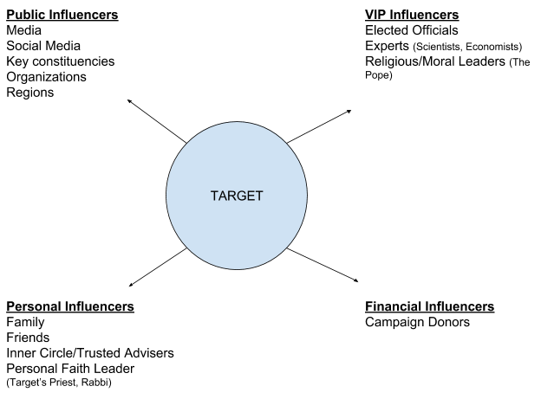
- Circle the ones who have the most influence over the target
- Star the ones that NWF has access to
- Prioritize the categories that have circles and stars
- Identify the top 3-5 best influencers to prioritize.

Power Mapping v. Stakeholder Mapping:
In reconciling these two exercises, it is important to consider the relationships you want to build for the long-term as well as those who have the most power today to help you win in the short term. This toolkit is designed both to create campaigns that win concrete policy victories and to build campaigns that set us up to build long-term power for our organizations – keep both goals in mind as you prioritize tactics.

Inventory of Assets:
This is an exercise to identify the key players or resources that are already in our sphere of influence that could make a difference and need to be engaged on this work. In particular, looking back at the hurdles/challenges you identified, what are your best tools for overcoming those challenges/countering opposition narratives?

- Internal Assets:
Example: Backyard Gardeners, Eco Leaders, Tribal Program, Affiliate
- ____________________
- ____________________
- ____________________
- ...etc.

- External Assets:
Example: Partner organizations/coalitions, legislative champs/offices
- ____________________
- ____________________
- ____________________
- ...etc.

Limitations/Challenges: Anticipate some of the challenges or hurdles that you are likely to face in winning on this campaign and influencing your targets. These will be critical to evaluate as part of the campaign plan. Who is your opposition on this campaign? Do they have power/influence with your targets? With relevant constituencies? Example: Target is up for reelection and will be more hesitant to take a stand
- __________________
- __________________

Step 1: Brainstorm Tactics!
One of the best uses of a big-group meeting is for brainstorming new ideas. So take advantage of all of the great thinkers in the room to brainstorm ideas for tactics on the campaign! Decisions about which ideas to pick, prioritize and what the specific expectations would be surrounding each tactic are better for smaller groups.

RULES:
- No bad ideas
- No budget
- No shooting anything down

Examples of Tactics:
- Constituency Engagement - Sign-on letters, postcards, petition/postcard, calls, turnout
- Members of Congress Activities - in-district meetings, lobby days, office deliveries / drops, phone calls, bird-dogging, teletown halls, townhalls, Twitter/Facebook
- Events - Tele-townhall, roundtables, coffees, statewide summit, site tours
- Generating Media – press events, LTEs, op-eds, editorial board, radio and TV, B-roll
- Paid Media - Banner and Facebook ads, radio ads, television ads
- Report - releasing publicly, raise profile of issue, tool for lobby visits, hill briefings

- Tactics:
- __________________________________________________________
- __________________________________________________________
- __________________________________________________________
- ...etc.

Step 2: Evaluate & Calendar - Once you have brainstormed a lot of tactics, it is time to evaluate each of them and place them on a calendar. Below are the key questions to ask about each tactic:

Evaluate:
- How does this tactic help us to achieve our campaign goal?
- How will this influence our target(s)?
- Does this tactic play to our strengths as an organization? Help us build a competency we are looking to improve?
- Do we have the budget, capacity to execute this tactic? If not, can we build the necessary budget or capacity on the timeline we have?

Calendar:
- How can the tactics you identified build on each other?
- Are we asking for too many tactics in July and not enough in November?
- Consider the milestones identified earlier, how do these influence your tactical calendar?

